Lumsden Primary School
Standards & Quality Report
2022 - 2023
&
School Improvement Planning
2023 – 2024

School Forward

We are pleased to present both our Standards and Quality Report for Session 2022- 2023 and our School Improvement plan for the current session 2023 -2024. This report forms part of our quality improvement framework and provides important information regarding our school’s progress to date and identifies our next steps in school improvement.
Self-Evaluation for Self-Improvement is at the heart of our practice in Lumsden Primary School. We continue to develop our practice in making robust use of evidence as a basis for judgements regarding the impact of our work on our learners.
How are we doing?
How do we know?
What are we going to do now?
Looking inwards to analyse our work
Looking outwards to find out more about what is working well for others locally and nationally
Looking forwards to gauge what continuous improvement might look like in the longer term
At Lumsden Primary School we continue to be committed to working closely with our community and all other stakeholders that support the education we provide. Together we are working hard to ensure all our pupils get the best possible start in life and are enabled and encouraged to maximize their potential.
We realise that within education things never stand still or stay the same. We continue to strive to meet the changes and challenges. Through this document we hope that you will get a sense of our developments, successes, and areas for further growth.

Joanne Brown
Head Teacher

The School and its context

- Vision for the school
- Values that underpin our work
- What we aim to achieve for our children/pupils
This graphic illustrates the Vision Values and Aims that we all aspire to and for our children.
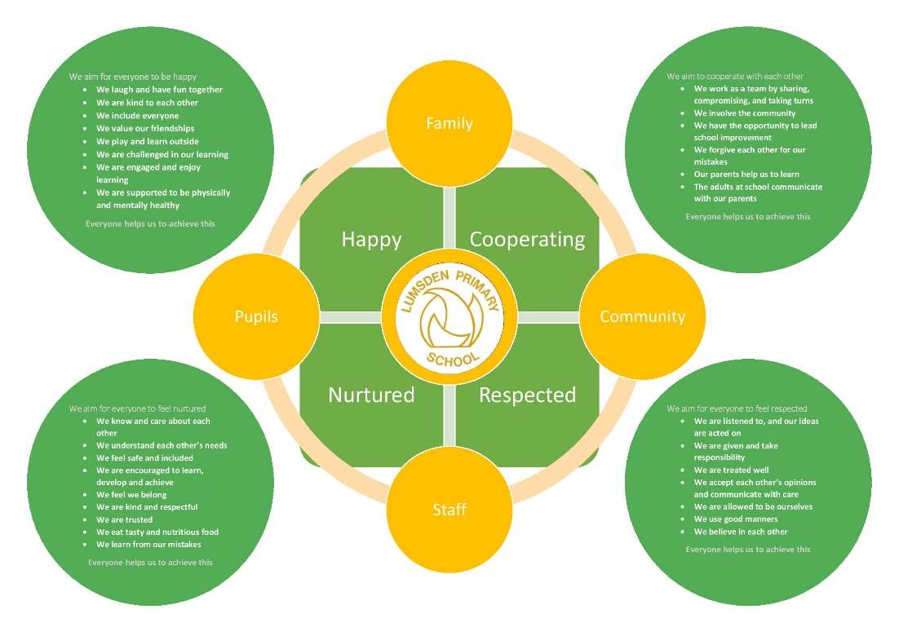
We also produced a version with the children, that supports their understanding of the ethos that they have helped develop.
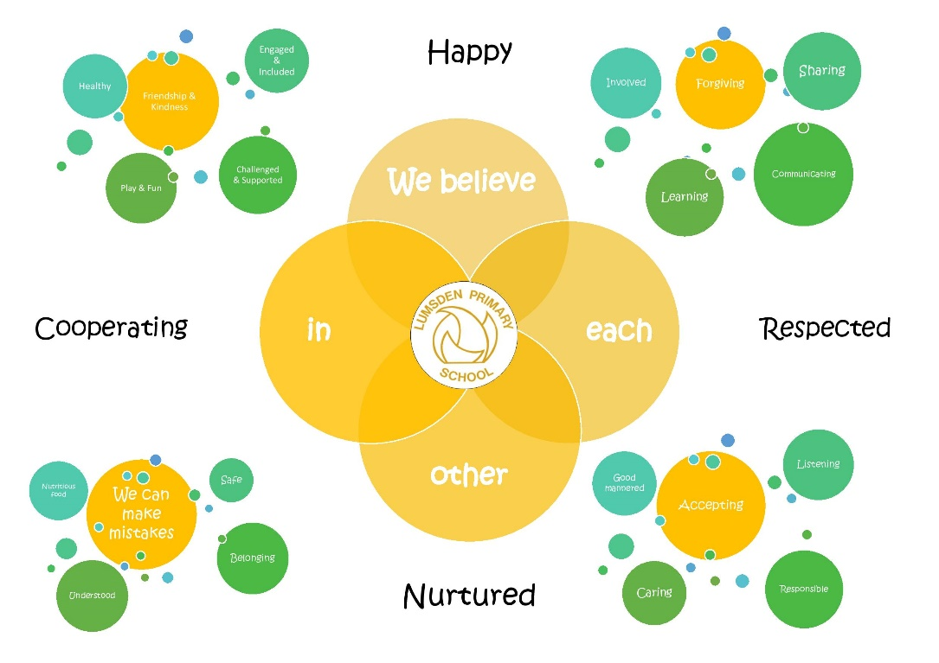
Context

Lumsden Primary School is a non-denominational school with a role of 14 across all stages. Most children fall into the SIMD decile 6. The school serves Lumsden village and the surrounding area.
Devolved budgets are managed in accordance with authority guidelines to support planned improvements in the school.
The school is active in the community and regularly participate in national and local fundraising. The school maintain a partnership with the Scottish Sculpture Workshop who are based in Lumsden Village. They collaborate with visiting artists on projects that cover all the Expressive Arts.

The school holds a bronze award as an Eco School and as a Rights Respecting School. We are working towards our silver award in both.

The children run a community café called the Moonlight Café. This is open to the community and supports the children’s skills for learning, life and work.

We use Growth Mindset principles to support pupils to maintain good Health and Wellbeing and develop into independent and confident learners.
This in turn supports the children to develop within the four capacities of the Curriculum for Excellence.

- Confident Individuals
- Responsible Citizens
- Successful Learners
- Effective Contributors

Impact of our developments
In this section we will outline the Targets we set last session and identify the progress we have made during session 2021-2022.
Key priority 2021-2022 | Key actions undertaken | Impact (achieved throughout 2022-2023
To develop consistency in teaching, learning and assessment | - Develop a statement of high-quality learning teaching and assessment.  - Develop high quality assessments to identify areas where skill transfer needs to be developed.  - Work with cluster colleagues to develop moderation in Literacy and Numeracy  - Revisit Shirley Clarke – Outstanding Formative Assessment and AiFL strategies to ensure good use of feedback  - Develop an observation proforma using Bruce Robertson’s model | - This has been developed using the Aberdeenshire quadrants – it needs to be shared with the parents and their views acted upon when relevant  - Overarching skills have been identified and shared with the children. Our planning needs to more clearly identify opportunities for High Quality Assessments – these should be developed depending on the contexts for learning rather than having a bank of assessments  - Learning rounds and professional dialogue were undertaken to support moderation in writing. A block of writing focusing on ‘Instructions’ will be observed and moderated using learning rounds with cluster colleagues next session. We have also created links with the English department at Alford Academy  - This was revisited and when reflected upon feedback and formative assessment strategies are strong. Peer feedback needs to be developed.  - The proforma has been developed to set out standards expected within a lesson and ensure a shared understanding within the staff team. The toolkit has supported teaching staff to reflect on the structure and content of lessons. We are more conscious of revisiting learning particularly in Numeracy daily, monthly and termly to ensure our learners are retaining the knowledge and skills previously learned.
To develop curriculum rationale and skills development | - Develop curriculum rationale that reflects the school curriculum  - Develop partnerships with local businesses and charities  - Use Seesaw to communicate children’s learning to parents across the curriculum | - The rationale has been refreshed and shared during sharing week with the parents. We need to continue to highlight to them the learning on a termly basis and how this fits into the longer term yearly plan so that parents can support learning at home.  - Developing the rationale highlighted the need to further develop partnerships in the community. Discussing skills with the children also indicated that the children need more input into understanding those skills that need developed for the world of work. We have begun to develop their understanding of the skills for work and how the community café supports these.  - Issues with data protection saw Seesaw being withdrawn. We looked at alternatives, but none provided the capacity for parent input and discussion that was important for communication of learning. We have introduced a ‘sharing week’. The first full week in each month parents can come in at the beginning or the end of the day to look at their children’s learning. This has had positive feedback from parents and has supported dialogue around the children’s learning
To develop outdoor learning | - CT & HT to undertake CPD that supports pedagogy of Outdoor Learning  - HT to develop practitioner enquiry to develop outdoor learning and measure impact  - Develop outdoor learning within the context of the curriculum rationale  - Develop area to side of school to support outdoor learning  - Develop large shed to be used as an outdoor classroom  - Engage with the Parent Council and Forum to fundraise for the above developments | - Time pressures this year have meant that this area of the improvement plan will need to be carried forward to next year  - Issues with obtaining consents and plans for this have meant that this has not happened  - Issues with obtaining consents and plans for this have meant that this has not happened  - The parent council have been fundraising and have secured a grant through the Wheedlemont fund to support the development of outside resources particularly gardening equipment. We have a gardening volunteer coming in one afternoon a week to support the children’s learning

How good is our leadership and approach to improvement?

QI 1.3 Leadership of change
Developing a shared vision, values and aims relevant to the school and its community
Strategic planning for continuous improvement
Implementing improvement and change
Relevant NIF priority: All
Relevant NIF driver(s): School leadership, Teacher professionalism, School improvement
Level of quality for core QI: 3
(HGIOS?4/HGIOELC? 1-6 scale)
How well are you doing?
What’s working well for your learners?
- All staff have a shared and consistent expectation of learning and behaviour.
- The Visions, Values and Aims were refreshed in 21/22. With a high percentage of new pupils this year (43%), the VVAs were reviewed with the class to ensure a shared understanding.
- We have recognised changes in the socio-economic context of the school and have been responsive to this.
- The vision supports all the children to achieve within the 4 capacities.
- The adults and older children in school model values, supporting the younger children to understand what the Visions Vales and Aims look and sound like
- The staff work collectively to drive change in the school that will support all learners to achieve.
- The HT and CT work closely together and are committed to school improvement. Collegiate is planned termly but is flexible as school improvement evolves through the year
- The HT with the support of the CT plan for improvement with learner attainment and welfare at the centre
- All staff are encouraged to engage in CLPL and the WTA is designed to ensure there is allocated time for this
- Staff are encouraged to be innovative in their teaching and are developing ways of measuring impact of new methods
- Learners are beginning to develop an understanding of critical thinking skills and staff are developing ways of including this within their planning
- The CT has undertaken further practitioner enquiry this year into Growth Mindset
How do you know?
What evidence do you have of positive impact on learners?
- Most children consistently show well-regulated behaviours and engage well with their learning
- Most children can discuss the Visions Values and Aims of the school and relate it to their relationships in school
- Most children show a good understanding of their rights and the rights of peoples across the globe. They can discuss that some children are not allowed their rights due to circumstances such as conflict and poverty
- SSNSA data shows that children are attaining well in both Numeracy and Literacy. Assessments in Numeracy suggest that most children are making good progress in Numeracy and samples of writing also show improvement in punctuation, grammar and spelling. Children are showing greater confidence in writing different genres of text.
- Most children can talk about their learning and can, with support, set learning targets in core subjects. The children are beginning to talk about skills for Life, Learning and Work including critical thinking skills. Some children can express which skills they use when running the community café.
- Some children can reflect on their learning and consider what they or their peers could do next.
- Some children can receive feedback from an adult or a peer and use this a positive way of moving forward with their learning.
What are you going to do now?
What are your improvement priorities in this area?
- The children need to take a greater responsibility for leadership, and we will consider how this can be achieved. Our ECO award application took longer than expected this year so we will focus on RRSA in the coming session. We will consider how the children can lead and have greater ownership over this award.
- Develop digital learning and look at how the children can gain greater ownership of this area
- Re-establish links with SSW and look for other opportunities to work with local business and 3rd sector.
- Work with self-improving school partners to develop greater consistency of quality improvement.
- Re-establish greater robustness of QA calendar

How good is the quality of care and education we offer?

QI 2.3 Learning, teaching and assessment
Learning and engagement
Quality of teaching
Effective use of assessment
Planning, tracking and monitoring
Relevant NIF priority: All
Relevant NIF driver(s): Teacher professionalism, School leadership, Parental engagement, Assessment of children’s progress
Level of quality for core QI: 3
(HGIOS?4/HGIOELC? 1-6 scale)
How well are you doing?
What’s working well for your learners?
- The school is well resourced including online subscriptions to support learning in Numeracy and Reading Comprehension. All the children have access to iPads and laptops which they use across learning
- The school uses community spaces such as the Village Hall to support the MacMillan Coffee Morning and local Mary Fair. There is an area of woodland that we use for outdoor learning. We also have extensive grounds that we use for learning outdoors. We mainly use outdoors for PE.
- The school offers after school and lunch time clubs – Netball, Games club, stop-motion, ECO and recorder. The older children are offered chanter lessons from a volunteer. We also have volunteer who comes in to support gardening.
- Digital technologies are used to support children to be independent in their learning. We use Google classrooms to assign learning activities. This is a ‘flipping the classroom’ strategy which is particularly good for challenging our more able learners. Universal supports such as ear defenders, ‘talk to text’ technology and other resources are available to all.
- The teaching staff plan together to ensure that all children are supported and challenged. Support staff are timetabled enabling all learners who require additional adult support the time required. Tracking meetings focus on how the children are doing and where they need to go next, allowing support and challenge to be monitored through the year. The body of evidence that is being used to make these professional judgements is improving.
- The staff have created a skills document that is being used to support the children’s understanding of the purpose of their learning. Children are beginning to talk using this document about their learning and the skills they are developing.
- Digital technologies are used across the curriculum using a variety of approved apps. For example, Minecraft has been used to support learning in RME, stop motion was used to support the understanding of the UNCRC.
- Assessment is embedded as part of the planning processes in Numeracy and Literacy. Formative assessment is visible in lessons and is used to ensure lessons are adaptive and support and challenge all learners. Out with Literacy and Numeracy, planning is being developed to make assessment opportunities clearer. This will include high quality assessments undertaken when these opportunities arise.
- Our interim reports in November were welcomed by our parents and support the conversations we have during Parent-Teacher consultation in late autumn.
- SNSA data is used to inform teaching and learning, and to support professional judgements of children at end of level.
- Numeracy assessments are used at beginning and end of topics. The beginning of topic assessment supports planning, and the end of topic gives us data about the effectiveness of the teaching and learning and pupil achievement. These also support our judgements around support and challenge needs.
- Having lost access to Accelerated Reader and the reading data that this brought, our ASL teacher has carried out reading tests with some children to Quality Assure our teacher judgements. Spelling and Phonics assessments are done regularly and support our judgements of when interventions need to be put in place and the impact of those interventions.
- Children are encouraged to support themselves and their peers with their learning. Resources such as the child friendly criterion scale are used with the children in writing to decide on next steps. Children are given opportunities to give feedback to each other in PE activities such as gymnastics and dance.
How do you know?
What evidence do you have of positive impact on learners?
- Some children are confident to ‘have a go’, make mistakes and learn from the feedback that is given by adults and some peers. Others are at the start of their Growth Mindset journey and are beginning to understand that it is okay to make mistakes and that is how they learn.
- The children’s achievements in school are celebrated at assembly using the celebration book. Out of school achievements are recognised through certificates for sport, an outstanding achievement, community and leadership. Most of the children are beginning to recognise some of the skills for life, learning and work that they practice while running the community café and within their daily learning.
- In addition to the community café some of the children have taken part in community activities such as Run Lumsden, a knitting workshop in partnership with the Scottish Sculpture Workshop, a sponsored walk up Tap O’ Noth and Run Balmoral.
- Most learners are beginning to use feedback to make improvements in their learning. The children set their own targets at the beginning of each term based on feedback in the previous term. Most children are using the ‘child friendly’ Criterion Scale to develop an area for development in their writing at the start of each block of writing.
- Some children are able to give feedback to their peers.
- The teaching staff have been using Bruce Roberton’s ‘The Teaching Dillusion to support improvements in learning and teaching. This has led to the use of knowledge organisers to support learning in Numeracy, Writing and Science.
- CT has undertaken a further course in Growth Mindset and is developing a practitioner enquiry to show if Growth Mindset can support children who need to use feedback more effectively.
- Planning is in development after refreshing the curriculum rationale – Science, RME and Social studies have been re-bundled and Experiences and Outcomes that are covered as part of annual learning have also been highlighted. Benchmarks have been added to annual learning to support planning for assessment.
- Formative assessment strategies are visible in lessons.
- Numeracy assessments are used pre and post learning of a block. The pre block assessment is used to target teaching and learning and next steps.
- Writing is taught as blocks of genre. The children write a cold piece which is assessed against the Criterion Scale to support focus of teaching and learning. Some children can identify areas that they need to develop. A hot task shows the effectiveness of the teaching and learning and next steps that need to be taken into the next block of writing.
- In the earlier years phonics and spelling is taught systematically and monitored regularly – support is put in place if any children are not demonstrating use of phonemes and spelling in written work.
- Tracking meetings are held 3 times a year. Benchmarks are used to support discussions and interventions are developed from these discussions. Staff are aware of any children that may need particular attention.
- Teaching staff are able to use the data available to them such as SNSA, spelling and phonic assessments, maths assessments and are able to make judgements about individual children and their next steps.
What are you going to do now?
What are your improvement priorities in this area?
- Develop context planning to increase pupil involvement
- Develop high quality assessments to support tracking of attainment in subjects out with Numeracy, Literacy and Health and Wellbeing
- Continue to develop planning to include skills, making these more visible to the children. Look for possible links to careers/local business
- Develop processes to assess effectiveness of interventions
- Undertake training and practitioner enquiry of Outdoor Learning
- Undertake training and practitioner enquiry of Play Based Learning
- Develop teaching and learning to include opportunities to develop use of digital technologies with all learners

How good are we at improving outcomes for all our learners?

QI 3.1 Ensuring wellbeing, equality and inclusion
Wellbeing
Fulfilment of statutory duties
Inclusion and equality
Relevant NIF priority: All
Relevant NIF driver(s): Assessment of children’s progress, School improvement, Performance information
Level of quality for core QI: 3
(HGIOS?4/HGIOELC? 1-6 scale)

How well are you doing?
What’s working well for your learners?
- All staff undertake GIRFEC training in term 1. There is a shared understanding of our responsibilities to all the children’s wellbeing. Whole staff meetings have a standing item where we discuss if pastoral notes require to be updated. The well-being indicators are used as a structure for our Health and Wellbeing curriculum and assembly planning. The UNCRC are highlighted in Health and Wellbeing planning and assembly planning. All staff are vigilant to the children’s mental and physical health and wellbeing
- All staff undertake Child Protection training in term 1 and have completed the Child Protection ALDO training. The HT is in the process of completing all the Child Protection training directed by the authority on ALDO
- We undertake questionnaires and well-being webs at least twice a year and more frequently if required to check in with the children and how they are feeling about school and relationships. The HT follows up on these questionnaires if there are any concerns about the children’s well-being.
- The VVAs focus on relationships and how we can support each other. The children helped to develop these and we spent time this year revising this as we had a big percentage intake of new children.
- The children are encouraged to make suggestions about how the school could change and develop – suggestion box, school improvement book and the celebration book. The HT also spends time with the children, using HGIOURS, to find out how they feel things are going and what they would like to see happen next.
- ‘Sharing Week’, established this year has helped us to communicate more frequently with parents. It has increased the opportunities for informal communications.
- Support is well planned and PSA and ASL teacher time is timetabled carefully to ensure all children are supported and challenged. This support and challenge is reviewed formally during tracking meetings but also professional conversations ensure the support and challenge remains flexible and based on ongoing assessment.
- All out children are tracked during the year using National Benchmarks and any support and challenge needs are identified quickly. SNSA data and classroom assessments are used to inform decisions about support and challenge.
- Our VVAs support inclusion and a recognition that we are all different. The children understand the difference between equality and equity and that all children need reasonable adaptations but these are not always the same.
- The assembly timetable includes celebrations and festivals from a variety of religions. The school is working towards it’s silver RRSA. The RME curriculum focuses on one world religion a year.
- The VVAs are used to support everyone’s understanding of inclusion and celebration of differences.

How do you know?
What evidence do you have of positive impact on learners?
- Staff demonstrate the use of nurturing and restorative language and behaviour with the children and each other. There is an ethos of mutual respect. There is also a shared understanding with the pupils that everyone can ‘get it wrong’ sometimes but accepting these mistakes as part of learning.
- Wellbeing and questionnaires demonstrate that most children feel safe and secure. They know that they can discuss difficulties with any adult in school or their parents at home. The ‘I need’ box was established recently and has been used by some children to share things that they need to talk about or would like resolved. Where children have expressed that there are difficulties, follow up conversations and interventions usually resolve these difficulties.
- Conversations and discussions during assemblies demonstrate that most children have a keen understanding of the UNCRC
- Most children are able to name the well-being indicators and give examples of how they support their well-being in school and at home
- All the staff have undertaken the required training in GIRFEC, Child Protection and the UNCRC.
- Curriculum and assembly planning shows coverage of World Faith festivals and celebrations and children in P3-7 can discuss some of the differences and similarities within these faiths. Assemblies that focus on the UNCRC have included article 39 Recovery from trauma and reintegration and article 15 Freedom of association. Most children demonstrated good understanding of these rights and showed empathy for children who may have suffered difficult starts to their lives.
- We use our school grounds regularly. Most PE is taught outside, and we look for other opportunities to learn outside. We use a local area of woodland to further develop outdoor learning. The school garden has been developed and a volunteer supports the children’s learning about growing things. The children are able to talk about the benefits of being outside.
What are you going to do now?
What are your improvement priorities in this area?
- CT to continue to develop Growth Mindset across the school
- Update VVAs
- Undertake training in CIRCLE inclusive practices
- Develop processes to evidence that interventions are effective
- Refresh nurture approaches
- Develop RSHP curriculum

QI 3.2 Raising attainment and achievement
Attainment in literacy and numeracy
Attainment over time
Overall quality of learners’ achievement
Equity for all learners
Relevant NIF priority: All
Relevant NIF driver(s): Assessment of children’s progress, School improvement, Performance information
Level of quality for core QI: 3
(HGIOS?4/HGIOELC? 1-6 scale)

How well are you doing?
What’s working well for your learners?
- Numeracy is well planned, and account is taken for each child’s need for support and challenge. Opportunities have been taken to provide targeted support through programmes delivered by PSAs. The main Numeracy programme is used as a structure for teaching and learning and the teachers use their own expertise to enhance this programme and use other resources if required.
- Writing has been taught using the structure of the Talk for Writing programme. Teachers use their own professional judgement and experience when using this programme to ensure all children are supported and challenged. Writing attainment is well evidenced using a ‘cold’ and ‘hot’ task to show each child’s progression.
- Phonics and Spelling is taught systematically and is assessed at regular intervals to ensure each child is attaining. Interventions are put in place if necessary, using this data. SNSA data is used to confirm professional judgment at the end of each level
- Tracking meetings are held 3 times a year and following this dialogue and dialogue with SfL colleagues, interventions are planned and delivered. Ongoing professional dialogue and assessments also gives us opportunities to plan short term interventions. SNSA data gives us evidence at end of Level that our judgements are correct
- Assemblies are used as opportunities to share children’s successes and wider achievements. These are recorded in our celebrations book. Children are awarded certificates - Community, Sporting, Leadership, and other Outstanding efforts. Care is taken to support all children to achieve these by giving opportunities through school such as the community café, Run Lumsden, Netball club. These certificates are displayed on our achievements board and then retained in our celebrations book
- We send out a Form each year when parents can tell us about their children’s wider achievements. We encourage parents to tell us about the ‘small stuff’ such as walking the dog, spending time doing crafts or cooking at home
- The school have achieved their ECO schools green flag award this year and we are working towards our RRSA silver award
- We use our school grounds regularly. Most PE is taught outside, and we look for other opportunities to learn outside. We use a local area of woodland to further develop outdoor learning. The school garden has been developed and a volunteer supports the children’s learning about growing things
How do you know?
What evidence do you have of positive impact on learners?
- Most of the children are achieving at their expected level in Numeracy and Literacy and some are attaining beyond their expected level.
- Moderation with Upper Donside cluster colleagues has supported understanding of levels achieved in writing.
- A focus on non-fiction genres in writing has supported most children to be confident in writing in other areas of the curriculum.
- Staff are familiar and confident in using national benchmarks to support professional dialogue around attainment of levels in Literacy and Numeracy
- We have worked with cluster partners to support P7 children with transition. This has included a residential trip with three other schools and a programme of activities with 5 other partner schools. The pupils and parents have expressed the effectiveness of these opportunities in reducing anxieties about transition to Alford Academy.
- We are at the beginning of our journey of developing the children’s understanding of skills for life, work and learning. Some of the children can identify skills they are using during learning. Most children are more confident in identifying which skills for work they are developing when running the community café.
- The HT uses HGIOURS to support the inclusion of children in the process of self-evaluation and school improvement. All the children are involved in this process. We have introduced a school improvement book and the children are encouraged to share their ideas of how things can be improved.
- Most children have good attendance and for those that have dropped below the expected level there has been a high level of support to get them back to good levels of attendance.
- All the children have attended community events run by the school, Parent Council, Scottish Sculpture Workshop or the Lumsden Community Association. These events have included the Scarecrow festival, MacMillan Café, Community Café, Knitting and Crochet Workshop and sponsored walk up Tap O’ Noth. The children speak about the pride in their achievements and their participation.
What are you going to do now?
What are your improvement priorities in this area?
- Develop peer observation timetable to allow staff to observe each other and visit partner schools. Implement the use of the Lesson Evaluation Toolkit to ensure focus for observations
- Continue to moderate Writing with partner schools and create links with Alford Academy
- Work with partner schools to develop moderation in other curricular areas – perhaps Numeracy
- Teaching staff to undertake practitioner enquiry on play-based learning
- Teaching staff to undertake practitioner enquiry on outdoor learning
- Reconnect with SSW and develop partnership to support Expressive Arts curriculum
- Develop processes to evidence that interventions are effective
- Develop QA calendar and re-establish good quality assurance practices
- Develop SfL calendar to ensure CT can have professional dialogue with SfL

PEF 2022-2023

Allocation - £5400 (Approximately £4300 spent on additional staffing from last year's budget & £162 3% admin charge) £938 to be spent this year
Identified gap  Linked to barriers identified through analysis of data | - Data shows that there is a need to develop Talking and Listening and Writing in the earlier primary years  - Observations are that the younger children need more opportunities to be directed during play to talk, turn take and share resources
Expenditure | - Class teacher employed for an additional 3 hours per week for 8 weeks to develop play - £860
Expected outcomes  What change do you want to see for learners? How much change? Who are the target group? By when | - Children to develop their Talking and Listening skills which will in turn support Writing development  - Children to be engaged in play opportunities with increasing independence  - Children demonstrate turn-taking independently of an adult
Impact Measurements  How will you know the change is an improvement? | - Observation of children’s engagement in learning – explore Luvean or Schlechty scales  - Tracking meetings using benchmarks and progressions to inform professional judgements show children attaining Early level in Listening and Talking & Writing by December 2023  - Children’s H & W questionnaires show positive feelings about learning

Capacity for improvement

School and staff are fully committed to the principle of continuous improvement. We wish to provide the very best for every child in our care. In this task, we are increasingly advised by performance data, such as pupil attainment data, so we can see clearly ‘what’ we need to improve.
We will continue to look inwards, outwards and forwards to prepare and equip our young people for their future. We will continue to work in partnership with parents, health professionals, and others to ‘get it right’ for every child.

National Improvement Framework Priorities | HGIOS and ELCC  Self-evaluation for self-improvement  - Leadership for learning  - Leadership of change  - Leadership and management of staff/practitioners  - Management of resources to promote equity  - Safeguarding and child protection  - Curriculum  - Learning teaching and assessment  - Personalised support  - Family learning  - Transitions  - Partnerships  - Improving/ ensuring wellbeing, equality and inclusion  Specific to HGIOS 4  - Raising attainment and achievement  - Increasing creativity and employability  Specific to HGIOELC  - Securing children’s progress  - Developing creativity and skills for life | Aberdeenshire Priorities:  - Improving learning, teaching and assessment.  - Partnership working to raise attainment.  - Developing leadership at all levels.  - Improvement through self-evaluation.
- Improvement in attainment, particularly in literacy and numeracy.
- Closing the attainment gap between the most and least disadvantaged children.
- Improvement in children and young people’s health and wellbeing.
- Improvement in employability skills and sustained, positive destinations.
Key drivers of improvement
School leadership

Teacher professionalism

Parental engagement

Assessment of children’s progress

School improvement

Performance Information
Priority 1 : To develop the curriculum to include greater opportunities for play and outdoor learning

What Data/evidence informs this priority? | Intervention | Expected Impact | Measures – what information will inform progress? | Actual Impact
- The demographic of the school next year will have a greater number of children in the younger years  - Some of the children have demonstrated a need to be physically active while learning  - Some children show greater engagement with their learning when they are able to move more often  - Some of the children require focussed learning with an adult, achieving more in short bursts of individual time rather than larger group learning  - Some parents included outdoor learning as something they felt was beneficial to their children’s learning | - CT to carry out a practitioner enquiry into play-based learning  - HT to carry out a practitioner enquiry into outdoor learning  - Develop P1-3 timetable to allow time for individual or paired support within times where play-based learning is ongoing  - Develop planning across the stages to include play and outdoor learning  - Planning for most subjects to be developed to include play and outdoor learning | Children to be engaged in learning  All children to be attaining at expected levels for age and stage in Literacy and Numeracy and Health and Wellbeing  Staff can target teaching to younger children leading to higher attainment  There is an increased use of the outdoor space for learning | - End of block numeracy assessments  - On-going phonics and spelling assessments  - Written Literacy evidence  - Observations of engagement with learning  - SNSA data

National Improvement Framework Priorities | HGIOS and ELCC  Self-evaluation for self-improvement  - Leadership for learning  - Leadership of change  - Leadership and management of staff/practitioners  - Management of resources to promote equity  - Safeguarding and child protection  - Curriculum  - Learning teaching and assessment  - Personalised support  - Family learning  - Transitions  - Partnerships  - Improving/ ensuring wellbeing, equality and inclusion  Specific to HGIOS 4  - Raising attainment and achievement  - Increasing creativity and employability  Specific to HGIOELC  - Securing children’s progress  - Developing creativity and skills for life | Aberdeenshire Priorities:  - Improving learning, teaching and assessment.  - Partnership working to raise attainment.  - Developing leadership at all levels.  - Improvement through self-evaluation.
- Improvement in attainment, particularly in literacy and numeracy.
- Closing the attainment gap between the most and least disadvantaged children.
- Improvement in children and young people’s health and wellbeing.
- Improvement in employability skills and sustained, positive destinations.
Key drivers of improvement
School leadership

Teacher professionalism

Parental engagement

Assessment of children’s progress

School improvement

Performance Information
Priority 2 To develop leadership opportunities for pupils

What Data/evidence informs this priority? | Intervention | Expected Impact | Measures – what information will inform progress? | Actual Impact
- The school achieved an ECO schools green flag award this year but as there had been a change of pupils involved in the ECO group it was observed that the children had less ownership over the award  - It has been observed that some of the children have been less keen to take responsibility for their learning  - The children have expressed an interest in developing lunchtime clubs  - The school would like to apply for their RRSA silver award, and the children need to be in greater control of the process  - Some children have demonstrated good leadership skills when supporting the younger children and other children need to work on these skills | - Re-instate pupil groups – these will be chosen and developed with the children but could be – digital leaders, RRSA/pupil council, ECO/gardening group, RSO  - Introduce pupil captains  - Use skills model to support children with their understanding of how their learning will be used in the world of work  - Look at possibility of ‘careers fair’ with partner schools  - Build relationships with community partners LCA and SSW – intergenerational project and Lumsden Newsletter | - All children have opportunities to lead  - Children feel that they are listened to and can influence changes in our school  - The senior pupils can support and lead the younger children in a respectful and effective manner  - The children will understand the skills they are developing for Life, Learning and Work  - Children will understand the options they have for careers and the skills that are linked  - The children can express how they are part of the Lumsden Community | - School attains their Silver RRSA award by July 2024  - School have developed their plan for their next ECO school award  - The children can discuss the skills associated with careers and jobs  - The children can talk confidently about the skills they are developing through their learning  - The children will demonstrate empathy for each other and can support each other in their learning

National Improvement Framework Priorities | HGIOS and ELCC  Self-evaluation for self-improvement  - Leadership for learning  - Leadership of change  - Leadership and management of staff/practitioners  - Management of resources to promote equity  - Safeguarding and child protection  - Curriculum  - Learning teaching and assessment  - Personalised support  - Family learning  - Transitions  - Partnerships  - Improving/ ensuring wellbeing, equality and inclusion  Specific to HGIOS 4  - Raising attainment and achievement  - Increasing creativity and employability  Specific to HGIOELC  - Securing children’s progress  - Developing creativity and skills for life | Aberdeenshire Priorities:  - Improving learning, teaching and assessment.  - Partnership working to raise attainment.  - Developing leadership at all levels.  - Improvement through self-evaluation.
- Improvement in attainment, particularly in literacy and numeracy.
- Closing the attainment gap between the most and least disadvantaged children.
- Improvement in children and young people’s health and wellbeing.
- Improvement in employability skills and sustained, positive destinations.
Key drivers of improvement
School leadership

Teacher professionalism

Parental engagement

Assessment of children’s progress

School improvement

Performance Information
Priority 3 : Develop digital learning opportunities

What Data/evidence informs this priority? | Intervention | Expected Impact | Measures – what information will inform progress? | Actual Impact
- As technologies have become integrated into the day to day learning there has been less need to teach digital technology as a discreet subject but having re-bundled the curriculum it has been identified that coding is not well covered and internet safety is not well covered in the health and wellbeing programme  - Both HT and CT do not feel that technologies are being used creatively and would like to update their understanding of pedagogy in this area  - Some children show high confidence when using technologies and others less so | - Review digital technology curriculum and identify gaps e.g. internet safety, coding, creative uses of technology  - Audit of digital technology – do we need to update anything e.g. downstairs smartboard, teacher iPads  - Review teacher training needs and attend LoveLearning courses  - Introduce pupil digital leaders that can support younger and less confident peers  - Introduce a lunch-time stop-motion club and possibly coding club | - Clear understanding of how to keep yourself safe online including; appropriate online communication, identifying what is real and what is fake, how to protect personal information, how to be respectful online, and who to go to for help.  - Increase in digital skills across the whole of the school community.  - Positive attitude towards technology in the classroom and a willingness to have a go.  - They will be able to talk about the extent to which they use digital technology to support their learning.  - Pupils will be able to increasingly demonstrate choice in how they complete/present tasks in line with their own learning needs.  - Pupils will be able to demonstrate their creativity and use digital resources in innovative ways | - Self-evaluation activity will be carried out at key points throughout the year to assess progress  - Pupils will be able to articulate how to keep themselves safe online and will demonstrate responsible use of technologies  - Pupils will be excited to share their work with peers, teachers and parents  - Feedback from staff will show that they are confident in supporting pupils to use their devices

 | August - November | November - March | March - June
SLT | - Find opportunities to observe outdoor learning in other schools (Crathie, Strathdon, Fordyce)  - Research pedagogy of outdoor learning  - Gather parent and pupil feedback about VVAs  - Finalise and follow QA calendar  - Begin to develop Lumsden Newsletter with senior pupils  - Confirm and advertise intergenerational project with SSW  - Moderation of writing follow-up with mini cluster and share findings with cluster  - Begin to develop processes for gathering evidence of impact of interventions  - CT annual review  - Set up pupil leadership groups  - Work with school captains to plan year  - RRSA silver plan  - Develop context planning with the children including skills  - Attend coding CLPL (4th October)  - Attend Minecraft CLPL (8th November)  - Attend digital learning INSET 17th November  - Develop P7 small school transition calendar  - Set up self-improving Trio meetings for the year  - Begin to develop RSHP curriculum using rshp.scot resources – send out info to parents  - Develop timetable to allow for ASL professional dialogue with ASL teacher  - Introduce pupil digital leaders that can support younger and less confident peers | - Find opportunities to observe outdoor learning in other schools (Crathie, Strathdon, Fordyce)  - Research pedagogy of outdoor learning  - Finalise new VVAs  - Ensure QA calendar is on track  - Continue to support senior pupils with Lumsden Newsletter  - Look at moderation of Numeracy(?) with mini-cluster partners  - Develop digital leaders with pupils  - Attend Internet safety CLPL (22nd November, 23rd January)  - Attend Thinglink CLPL (5th March)  - QA calendar review  - Organise careers fair for Mini Cluster joint day  - Develop context planning with the children including skills  - Continue to develop RSHP curriculum using rshp.scot resources  - Continue intergenerational project with SSW  - Develop P7 small school transition calendar  - Interim Reports  - Review digital technology curriculum and identify gaps e.g. internet safety, coding, creative uses of technology  - Audit digital technology – do we need to update anything e.g. downstairs smartboard, teacher iPads | - Continue to develop outdoor learning as part of the curriculum – assess impact and plan next steps. Develop a rationale/progression  - Attend coding CLPL (20th March)  - Attend Internet safety CLPL (15th May)  - Finalise and apply for Silver RRSA accreditation  - QA calendar review  - Develop P7 small school transition calendar  - Review digital training and look at progression of learning for children. Review how the digital leaders have performed and plan next steps  - Review work with school captains and plan next steps  - – write standards and quality report  - Engage with stakeholders on improvement priorities for next year
Staff | - Engage with QA calendar  - Find opportunities to observe play in other schools (Tough, Alford, Crathie)  - Research pedagogy of play-based learning  - Attend coding CLPL (4th October)  - Attend digital learning INSET 17th November  - Support HT with RRSA development  - Support school leadership groups  - Work with HT to develop processes around gathering evidence of impact of interventions  - Develop context planning with the children including skills  - Begin to develop Lumsden Newsletter with senior pupils  - Support HT with RSHP planning | - Engage with QA calendar  - Find opportunities to observe play in other schools (Tough, Alford, Crathie)  - Continue to support senior pupils with Lumsden Newsletter  - Play leaders P6/7  - Attend Thinglink CLPL (5th March)  - Help organise careers fair for Mini Cluster joint day  - Develop context planning with the children including skills  - Support HT with RSHP planning  - Support HT with intergenerational planning | - Attend coding CLPL (20th March)  - Train and implement play leader training with P4/5  - Continue to develop play as part of the curriculum – assess impact and plan next steps  - Review school improvement plan and QA calendar  - Engage with stakeholders on improvement priorities for next year  - End of Year Reports
Parent forum | - Engage with school communications and return permissions and information forms promptly  - Engage with information sent out about RSHP (relationships, sexual health and parenthood)  - Attend Sharing weeks  - Attend Parent – teacher consultation  - Support children with homework  - Attend open events as advertised  - Support the Parent Council by attending meetings and helping at events | - Engage with school communications and return permissions and information forms promptly  - Engage with school to develop play and outdoor learning  - Attend sharing weeks  - Support children with homework  - Support Community Café  - Attend open events as advertised  - Support the Parent Council by attending meetings and helping at events | - Engage with school communications and return permissions and information forms promptly  - Engage with school to develop play and outdoor learning  - Attend sharing weeks  - Support children with homework  - Support Community Café  - Attend Parent – teacher consultation  - Discuss End of Year report with your child  - Attend open events as advertised  - Support the Parent Council by attending meetings and helping at events  - Give feedback on the year’s school developments and engage with next year’s plan
Pupils | - Support the adults by giving feedback about how you are getting on with your learning  - Set your own targets for term 1 & 2  - Read at home  - Complete homework and hand in on time  - Actively take part in Pupil council and support the adults to work towards our silver award as a Right Respecting School  - Share your learning with your parents during sharing week  - Come to school prepared, smartly dressed and ready to learn  - Bring PE kit to school | - Set your own learning targets for term 3  - Complete homework and hand in on time  - Actively take part in Pupil council and support the adults to work towards our silver award as a Right Respecting School  - Support Community Café  - Share your learning with your parents during sharing week  - Come to school prepared, smartly dressed and ready to learn  - Bring PE kit to school | - Complete homework and hand in on time  - Actively take part in Pupil council and support the adults to work towards our silver award as a Right Respecting School  - Begin to think about our next ECO school award  - Share your learning with your parents during sharing week  - Support Community Café  - Support adults in assessing school improvements and setting targets for next year  - Come to school prepared, smartly dressed and ready to learn  - Bring PE kit to school

Wider Achievements

Lumsden Primary School | Facebook
Lumsden Primary School (@LumsdenPriary) / Twitter

Wider Community Links

MacMillan Café run with LCA – September 2022
Harvest Service in Lumsden Church – October 2022
Halloween Scarecrow Festival – October 2022
Junior Cop Initiative with Police Scotland – November 2022
Laying of poppies on Armistice Day – November 2022
Day of Dance with Upper Donside and Crathie Schools – November 2022
Community Carol Service – December 2022
Knitting and Crochet Workshop with SSW – February 2023
YMI Where I Am song writing workshop – February/March 2023
Joint cluster day – World Book Day celebration ‘Lighthouses’ – March 2023
School performance of Tuishi Pamoja – April 2023
Run Lumsden – May 2023
Mary Fair – May 2023
Joint Sports Day with Upper Donside Schools – May 2023
Kildrummy Kirk Art exhibition – June 2023
Pottery workshop with SSW – June 2023
Team Marr Netball club – run all year with cluster partners
Community Recycling Hub run with Terracycle
Moonlight Café - run a throughout the year

